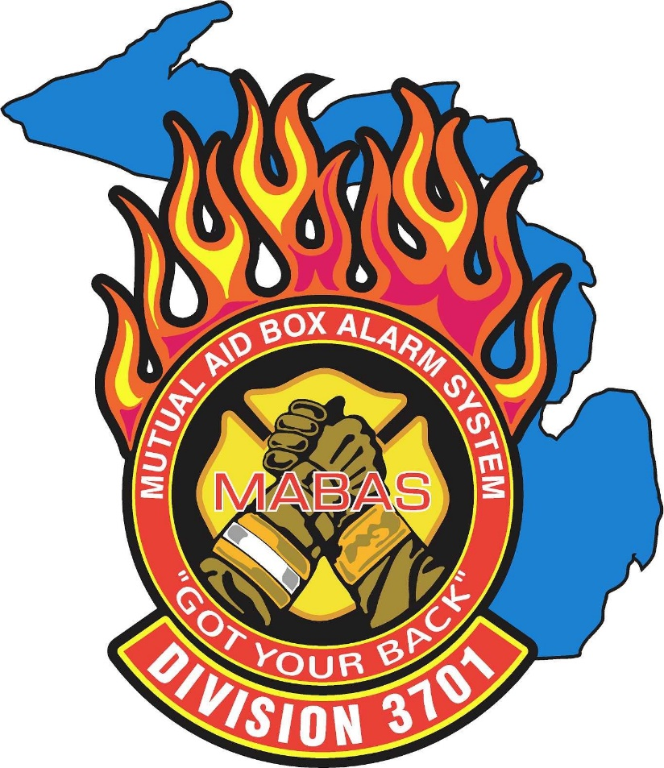

HAZMAT – TECHNICAL RESCUE

SPECIAL OPERATIONS
TEAM MEMBER APPLICATION

APPLICATION INSTRUCTIONS

- Fill out the application in its entirety, including the “Completed Training” section. Include all training you have received in Special Operations (Hazmat / Technical Rescue), regardless of which discipline you are applying for.
- The following documents must be submitted along with the completed application:
- Training Certificates
- Medical Surveillance Forms
- General minimum requirements for all Special Operations team members include:
- Member of a MABAS 3701 department or organization.
- Successful applicants shall be of good personal character and void of moral turpitude.
- Documented authorization of department employment and permission of the applicants Chief / Supervisor to serve on the team.
- Documentation of provision of Worker’s Compensation Insurance from the applicant’s employing department.
- General minimum certifications to become a probationary member include:
- Michigan Firefighter I & II Certification.
- Michigan EMT-B Medical License.
- IS-100, IS-200, IS-700, and IS-800 Certifications. IS-300 and IS-400 required for management positions.
- Two years of emergency service experience.
- Hazmat Operations Level (Probationary Member – Hazmat)
- Technical Rescue Awareness Level (Probationary Member – TRT)
- General minimum requirements for the Hazardous Materials Team include:
- Documented compliance with the minimum physical requirements as stated in 29 CFR 1910.120(q)(9). The costs associated with medical surveillance shall be at the expense of the applicant’s employing fire department.
- Certification of training to the Hazardous Materials Technician level according to 29 CFR 1910.120(q)(6)(iii).
- Hazmat Officer Certification for personnel in hazmat specific management positions.
- General minimum requirements for the Technical Rescue Team include:
- Documented compliance with the minimum physical requirements as stated in 29 CFR 1910.120(q)(9). The costs associated with medical surveillance shall be at the expense of the applicant’s employing fire department.
- Certification of training that demonstrates the applicant qualifies to act as a Rescue Technician within the following disciplines:
    - Rope Rescue
    - Confined Space Rescue
    - Ice / Water Rescue
    - Structural Collapse Rescue
    - Trench Rescue
- Probationary members must complete the team minimum membership qualifications in their respective discipline in a reasonable time frame. Only qualified members will become deployable.
- The Special Operations Command may consider knowledge, skills, and abilities over and above minimum requirements in making final selections for team membership.
- Expense reimbursements for training and/or deployments from governmental units such as MI-MABAS, the Michigan Emergency Management Agency (MEMA) or the Federal Emergency Management Agency (FEMA) shall be requested and dispersed according to the local policy of a team member’s employing fire department. Coordination of such requests and subsequent disbursements shall be the joint responsibility of the Special Operations Command and the Department Directors.

Application for Membership
MABAS 3701 Special Operations

(Select One)

Haz-Mat Team Member ☐
Haz-Mat Probationary Member ☐

Technical Rescue Team Member ☐
Technical Rescue Team Probationary Member ☐

Incident Management Team (IMT) ☐

APPLICANT INFORMATION

Name______________________________________________

Home Address_______________________________________

City/Town_________________________ Zip___________

Email_____________________________________

Home Phone_______________________________

Work Phone________________________________

Cell Phone_________________________________

List all Fire / EMS Organization(s) where you have been a past employee:

Department / Agency Dates of Employment

________________________________ _______________________

________________________________ _______________________

________________________________ _______________________

________________________________ _______________________

Application for Membership
MABAS 3701 Special Operations

EMERGENCY CONTACT(S)

Name______________________________________________

Home Address_______________________________________

City/Town_________________________ Zip___________

Email_____________________________________

Home Phone_______________________________

Work Phone________________________________

Cell Phone_________________________________

Name______________________________________________

Home Address_______________________________________

City/Town_________________________ Zip___________

Email_____________________________________

Home Phone_______________________________

Work Phone________________________________

Cell Phone_________________________________

Application for Membership
MABAS 3701 Special Operations

PRIVATE SECTOR INFORMATION

Name of Current Affiliation_________________________________________________

Address_______________________________________________________________

City/Town______________________________________ State______ Zip__________

Dates Employed__________________ Current Position_________________________

List any relevant private sector experience as it relates to Special Operations (Hazardous Materials or Technical Rescue):

RELEVANT PRIVATE SECTOR CERTIFICATIONS (Select all that apply)

Environmental Specialist ☐

Chemist / Biologist ☐

GIS ☐

Engineer ☐

Structural Engineer ☐

Licensed Builder ☐

Coxswain ☐

Other____________________ ☐

Application for Membership
MABAS 3701 Special Operations

COMPLETED TRAINING

Check below all certifications you have completed whether it is in the area you have applied for or not. Include the training provider, such as a public/government agency or corporate entity.

A copy of all certifications must be submitted with this application.

Basic Team Certification Requirements:

Firefighter I & II ☐
Date Completed__________________________

EMT-B License (or Higher) ☐
Date Completed__________________________

Apparatus Drivers Training ☐
Date Completed__________________________

Fire Officer I & II (Management) ☐
Date Completed__________________________

Hazardous Materials Operations ☐
Date Completed__________________________

Technical Rescue Awareness ☐
Date Completed__________________________

IS-100 – Intro to ICS ☐
Date Completed__________________________

IS-200 – ICS for Single Resource ☐
Date Completed__________________________

IS-300 – Inter. ICS for Exp. Incidents (Management) ☐
Date Completed__________________________

Application for Membership
MABAS 3701 Special Operations

IS-400 – Advanced ICS (Management) ☐
Date Completed__________________________

IS-700 – (NIMS) an Introduction ☐
Date Completed__________________________

IS-800 – National Response Framework ☐
Date Completed__________________________

List additional Advanced Certifications or Degree:

Application for Membership
MABAS 3701 Special Operations

Hazardous Materials Team Certification Requirements:

Hazardous Materials Operations ☐
Date Completed__________________________

Hazardous Materials Technician I ☐
Date Completed__________________________

Hazardous Materials Technician II ☐
Date Completed__________________________

Hazmat IQ Course ☐
Date Completed__________________________

Hazardous Materials Officer (Management) ☐
Date Completed__________________________

Hazardous Materials Specialist (Optional) ☐
Date Completed__________________________

Chemistry I & II (Optional) ☐
Date Completed__________________________

Highway Cargo Specialist (Optional) ☐
Date Completed__________________________

Flaring Operations (Optional) ☐
Date Completed__________________________

Product Transfer Specialist (Optional) ☐
Date Completed__________________________

List any additional Hazardous Materials Certifications:

Application for Membership
MABAS 3701 Special Operations

Technical Rescue Team Certification Requirements:

Technical Rescue Awareness ☐
Date Completed__________________________

Rope Rescue Operations ☐
Date Completed__________________________

Rope Rescue Technician ☐
Date Completed__________________________

Confined Space Rescue Operations ☐
Date Completed__________________________

Confined Space Rescue Technician ☐
Date Completed__________________________

Structural Collapse Rescue Operations ☐
Date Completed__________________________

Structural Collapse Rescue Technician ☐
Date Completed__________________________

Trench Rescue Operations ☐
Date Completed__________________________

Trench Rescue Technician ☐
Date Completed__________________________

Swiftwater / Ice Rescue Technician ☐ ☐
Date Completed_____________/_____________

List any additional Technical Rescue Certifications:

Application for Membership
MABAS 3701 Special Operations

Authorization

I, being an active member of______________________________________________ do hereby apply for membership with the MABAS Division 3701 Special Operations Teams.

I hereby authorize and empower MABAS Division 3701 through its authorized representatives, any consumer reporting agency, or other outside service company engaged by the Division for this purpose, now and subsequently, to obtain, prepare, use, and furnish information concerning my current and former employment, education, credit, general reputation, health, personal characteristics, driving record and mode of living, through correspondence and/or personal interviews with friends, neighbors, associates or others with whom I am acquainted or who may have knowledge concerning any of the above items.

Upon written request, I understand that the Division will provide me with information regarding the scope of the investigation, if one is made.

I have read and understand the requirements for membership and by my signature below, agree to them. I certify that the information on this application is true and correct to the best of my knowledge.

______________________________________________________________________
Application Signature Date

Supervisor Authorization

I, the Chief Officer / Supervisor at___________________________________________ certify that the above-named applicant is an active member in good standing of this organization.

I understand that the responsibility for workers compensation insurance and compensation coverage regarding all wages, training, certifications, equipment, and deployment remains with our department or organization.

The above applicant has my permission and support to become a member of the MABAS 3701 Special Operations Team.

______________________________________________________________________
Authorized Supervisor Signature Date

